**Tips and Tools for Lockdown**

**Funded by**

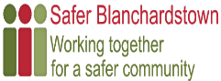

Recreation & Fitness

We are truly fortunate to have numerous walking/jogging/running routes located on our doorstep. 30 minutes of physical activity can help reduce stress, improve mental health and increase overall fitness. **Walks & Hikes in and Close to Mountview/ Blakestown:**

• Millenium Park

• Hartstown Park

* Tolka Valley Park

**FREE exercises programmes** available online.

https://learning.fingal.ie/ click “**Be Active At Home**” for a range of fitness activities such as Homefit classes: Body, Mind Movement, Abs Class & Chair Exercise, Digifit Workout Series, Skills Bingo and much more.

Click on “**Sports Con**” for school activities.

Baking & Cooking

***Fancy passing the time with some family fun cooking?***

* **Cooking with kids/young people**

[*www.bbcgoodfood.com/recipes/collection/kids-cooking*](http://www.bbcgoodfood.com/recipes/collection/kids-cooking)

* **BBC Recipes for Teenagers**

[*www.bbcgoodfood.com/howto/guide/recipes-teenagers*](http://www.bbcgoodfood.com/howto/guide/recipes-teenagers)

**Healthy Food Made Easy** is a peer-led, 6 session course (2½ hours per session), covering nutrition theory & a practical cookery element. The emphasis is on group learning rather than formal teaching.

The course is open to anyone aged 16yrs+, interested in learning about nutrition, reading and understanding food labels, and wanting to eat healthy, nutritious and delicious food while maintaining a budget. The course is available via Zoom or WhatsApp.

For more information, contact Suzanne Bayley at ***sbayley@empower.ie***

**Baby Food Made Easy** is a one session workshop for parents/guardians of babies aged 3-9 months, who are ready to start spoon-feeding or may have already started the weaning process. The information provided during the workshop is in accordance with the current guidelines from the Department of Health and Children.

The workshop covers topics including,

signs that baby is ready to start weaning,

what foods to give first,

the stages of weaning, finger foods,

food allergies and many more.

For more information contact Suzanne Bayley – [***sbayley@empower.ie***](mailto:sbayley@empower.ie)

The Mountview/Blakestown Task Group would like to offer support to you and your family as we all try manage as best we can through restrictions due to COVID 19. It is difficult to manage the many challenges presented to us, so here are some practical suggestions and ideas to help. We hope that the information will be of benefit.

Mental Health

**HSE Stress Control** – *www. stresscontrol.ie*

Free programme, with videos available online. Stress Control is an evidence-based programme that teaches you practical skills to deal with stress.

**Minding Your Wellbeing** – *www.hse.ie/eng/about/who/healthwellbeing*

Free video-based well-being programme. Developed by HSE Health and Wellbeing, it’s an opportunity for people to learn more about mindfulness, gratitude, self-care and resilience.

**Healthy Fingal - Keep Well – (01 8905080)** *www.fingal.ie/healthyfingalwellbeing*

Information on supports available in Fingal, more details will be added as information becomes available.

**Suicide Awareness Dublin 15**

Suicide Awareness Dublin 15 have been

manning the phone right throughout the

Covid19 pandemic providing support to those in

our community in need.

If you or anyone you know would like some

support, please contact us at any time

**Unlimited Mobile Data for Students**

Mobile providers have confirmed they will continue to provide learners with affordable unlimited mobile data packages during this time during level 5. Visit [***www.aontas.com***](http://www.aontas.com) and search MOBILE

DATA using the search button on right hand side

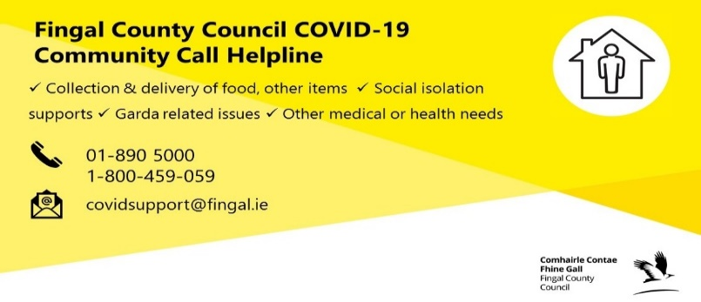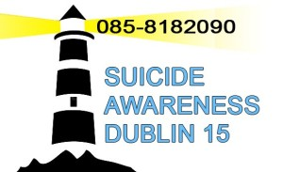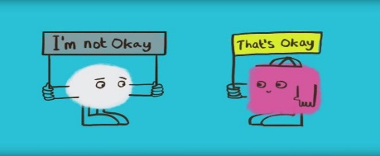

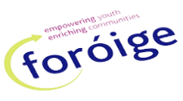

**Foroige** is the leading youth organisation in Ireland and has been working with young people aged between 10 - 25-year-olds. Our purpose is to enable young people to involve themselves consciously and actively in their development and in the development of society.

As part of Foroige, Corduff Community Youth Project (CCYP) aims to empower young people to be proactive in their own development and to realise their maximum potential, by respecting their rights and hearing their own voices, while protecting and supporting their transition from childhood to adulthood. We do this through the provision of; various outcome focused youth work programmes, activity-based health and well-being programmes, individual and group work programmes as well as other supportive services and projects.

For more information on a range of services please contact: **Jane Jameson, Youth Officer with the WEB Project 0860081183**

**Laura Callaghan, Youth Project 0861833460, Kieron Cummins, Youth Project 0868180890, Laura Curtis, Youth Officer, Drugs Prevention and Education Project 086 822438**

**Open 8am to 8pm seven days a week**



Cocooning Activities

**Cocooning - A collection of activities for those self-isolating**

Enjoy interesting facts, short stories, poetry, recipes, songs, gardening tips, puzzles, activities, information on support services available for those cocooning and self-isolating. The Cocooning activities booklet can be view at [***https://www.fingal.ie/news/cocooning-collection-activities-those-self-isolating***](https://www.fingal.ie/news/cocooning-collection-activities-those-self-isolating)

**Age Friendly Fingal Magazine**

A new magazine is being produced for end of January 2021 to follow up on the cocooning activities booklet. This new publication will be approx. 70 pages and include short stories, puzzles, poetry, recipes and local information about Fingal. If you would like your name included in our mailing list to receive a magazine, please email [community@fingal.ie](mailto:community@fingal.ie)

**Memory Makers**

Fingal County Council’s Community Development Office “Memory Makers - Reflections and Recollections Cocooners Special Edition 2020”, features inspirational poems and short stories from Cocooners across the County. The beautifully designed publication celebrates the voices of Cocooners, reflecting and recollecting on memories, current or past events or fictional work inspired by these unprecedented times we are living through. The breadth and depth of the written work is truly impressive.

This publication is an important historical document and can soon be found in Fingal Libraries, Fingal Local Studies & Archives as well as in the National Library of Ireland and the National Museum of Ireland collections. A soft copy of the publication is available on the Fingal County Council website.

[***www.fingal.ie/news/memorymakersreflectionsandrecollections***](http://www.fingal.ie/news/memorymakersreflectionsandrecollections)

Online Education

***Community Education***

61 Tutor led video courses from Spanish to Horticulture, Drama, Face Massage and much more are available at Blanchardstown Adult Education Service on YouTube

**Best Foot Forward Training Programme**

Looks at; Mock interviews/Digital Skills/Online Jobseekers/Social media/Online construction skills/catering skills/childcare training/Manual handling amid other opportunities.

If interested contact Melanie Doyle at 018209550 or mdoyle@empower.ie

Free Jobs Club Programme

|  |  |
| --- | --- |
| CV preparation | CV Design |
| Cover Letters | Telephone Skills |
| Interview Skills | Confidence Building |
| Computer Skills |  |

**Contact *maspin@empower.ie***

Blakestown Community

Resource Centre

We have made several changes to our facilities to provide additional safety measures to better protect people against COVID-19. This included purchasing new IT equipment to assist with running online classes and placing sanitisation stations throughout the buildings. We will be increasing our operational hours once level 3 restrictions are reduced and welcome any ideas the local community may have in terms of running both physical & virtual classes, we are also committed in supporting new & existing groups wishing to return to use the Centre facilities when safe to do so.

Online Ideas & Activities for

Young & Old

**FREE ONLINE ACTIVITIES FOR ALL AGES**

*www.theidearoom.net/free-online-activities/*

**PLAY DOUGH RECIPE**

*www.iheartnaptime.net/play-dough-recipe/*



Tips, Supports & Resources

**Parenting Plus Training**

Support for Parents in “Difficult Times” both on-line and by Phone.

Evidenced based Solution Focused Programs that work.

Contact [***admin@parentplus.ie***](mailto:admin@parentplus.ie)Phone; 018545158

**Support Groups Contact Details**

St Vincent de Paul 018237953

Crosscare 018219892

**Practical Tips for Covid 19**

Make sure and open your windows regularly to change the air.

In minding mother nature and caring for the earth use Recyclable masks where possible.

**Tobacco Free Fingal**

A healthy start to 2021 is to quit smoking. The We Can Quit programme for women will start again in February 2021. This offers an opportunity for women to quit smoking with the help of FREE Nicotine Replacement Therapy. Places are filling up so if you are interested get in touch. **Contact Sue Fox 0879683020 –** [***sfox@empower.ie***](mailto:sfox@empower.ie)

Cocooning Library /Christmas Tree of Hope

Are you cocooning at home? Read everything on your bookshefl?

Looking for some new reading material? Fingal Libraries are here to help!

If you or someone you know is cocooning and would like a fresh supply of library books, talking books or DVDs, we can deliver to your door. Contact us now on 01 8906719 or email cocooning.library@fingal.ie

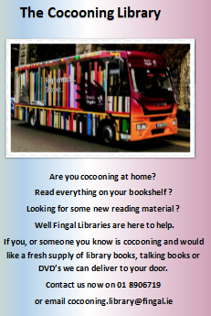

Reduce – Reuse - Recycle

Christmas brings stress and pressure to most families,

not least what to do with all the boxes, packaging,

cans, bottles and food waste.

So let’s all do our little bit and ensure we keep our community clean, Green and Safe by disposing of our waste properly.

------------------------------------------------------------------

**Coolmine Recycling Centre Christmas Opening Times**

**Christmas Eve Dec 24th, Closing 1.00pm**

**Dec 25th, 26th, 27th CLOSED**

**Dec 28th 29th, 30th OPEN**

**Dec 31st Closing 1.00pm**

**Jan 1st CLOSED**

**Jan 2nd OPEN**

**Christmas tree Collection point available 2nd to 17th January 2021.**

Fingal County Council will be accepting Christmas Trees for recycling at Millennium Park Car Park,  Snugborough Road Extension, Coolmine  – park opening hours only.Please note that ***only*** Christmas trees will be accepted, other green waste, Christmas tree stands, etc. will ***not be accepted***

Safer Blanchardstown | Dublin 15 local community and services index -  working together for a safer community

**Mountview Family Resource Centre** would like to invite you to come along and place a star on our Annual Christmas Tree of Hope. It’s an opportunity to remember those dear to us at Christmas. Call anytime between 10am and 4pm Monday to Friday Mountview Family Resource Centre 11 Whitechapel Crescent Tel: 8206171

**WE WOULD LIKE TO WISH ALL RESIDENTS AND FRIENDS OF MOUNTVIEW/BLAKESTOWN A VERY HAPPY, HOLY AND PEACEFUL CHRISTMAS & PROSPEROUS NEW YEAR**

Don’t Let Thieves Away with it

Burglars and other thieves should not be allowed get away with your valuables. Secretly mark your valuables (laptop, tools, bike, etc.) with your unique **Eircode number using a UV pen or scratch on with a nail.** Gardaí now examine all

recovered items with UV light

to identify and return property to their legal owner



