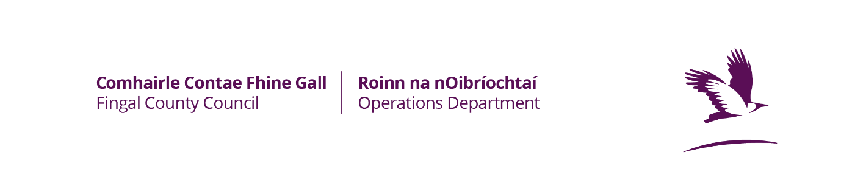
For Official Use Only | Total No | Amount Due

Membership

Admin Fee

Total

Application for Season 2023-2024

Form to be filled in Block Capitals
Name of Tennis Club

Please complete this section in full
Contact Person | Address | Mobile  Home/Work
Contact Email Address:

Does your Club have a Current Public Liability Insurance policy Yes/No
Is Fingal County Council specifically indemnified on your policy Yes/No

Insurers | Policy Start Date | Expiry Date | Policy No

I hereby certify that I have read and accept the Conditions of Pitch Allocation and certify that the information contained within this application is true and I agree that any inaccuracies regarding the information or breach of the conditions may result in your school having its allocation for all its teams withdrawn for a period of up to one calendar year.

Signature of School Official making application: (please note, all correspondence will be directed to this person)

Signature: ___________________________________ Position Held: ____________________________

Block Capitals _________________________________

Check List : 1. Completed Application Form □
2. Letting Fee □ 3. Insurance (with indemnity to Fingal County Council) □
Tick as appropriate

Tá leagan Gaeilge den fhoirm seo ar fail

