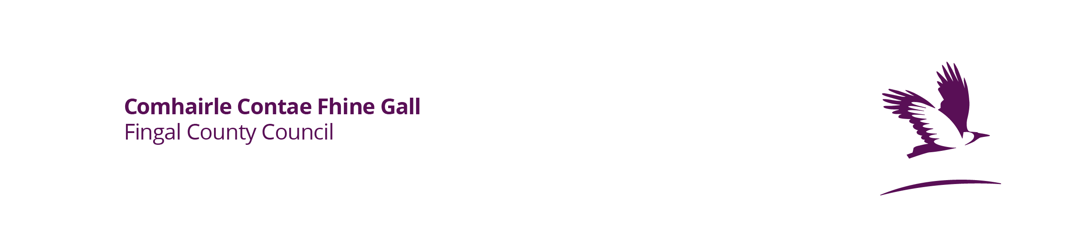
Dry Cleaners –
New/Renewal Application Form for the Certificate of Compliance

1. Name, address, email, contact phone number for the operator:

2. Address of the Dry-Cleaning premises if different from 1 above:

3. (a) Have you previously been issued with a certificate for this installation? Yes/No (Cross out as appropriate)
(b) If yes to 3(a), please state the date of expiry of the previous certificate:

4. State the activity or activities carried out or proposed to be carried out at the installation by reference to Schedules 1 and 2 of the Regulations

5. Detail the type or types of organic solvent used or proposed to be used in the activity or activities:
6. State the estimated quantity of each type of organic solvent consumed or proposed to be consumed annually in each activity:

7. Will abatement equipment be used or is it used currently- If so, briefly describe:

8. Are you employing, or do you propose to employ, a solvent reduction scheme under Regulation 10(1)(b). If so, detail briefly any reduction targets to be achieved:

Enclosed*:
❒ Enviroguide Report on the compliance of the dry cleaning installation; and

❒ Payment/proof of payment of application fee of €50/€70 payable to the local authority

Signature..................................................................

Date..................................

*Please submit the competed application form, Enviroguide report and payment/proof of payment of application fee either in hardcopy to the Environment Section, Fingal County Council, County Hall, Main Street, Swords, Co. Dublin, K67 X8Y2 or via email to enviroment@fingal.ie.

The fee must be paid at the time of application. This can be paid either via cheque or over the phone with the Fingal County Council Cash Office Section (01-8905154) between 9.30am – 15.30am Monday to Friday. Please quote reference code ‘EN063 Solvents Directive – Cert’ at the time of payment.

