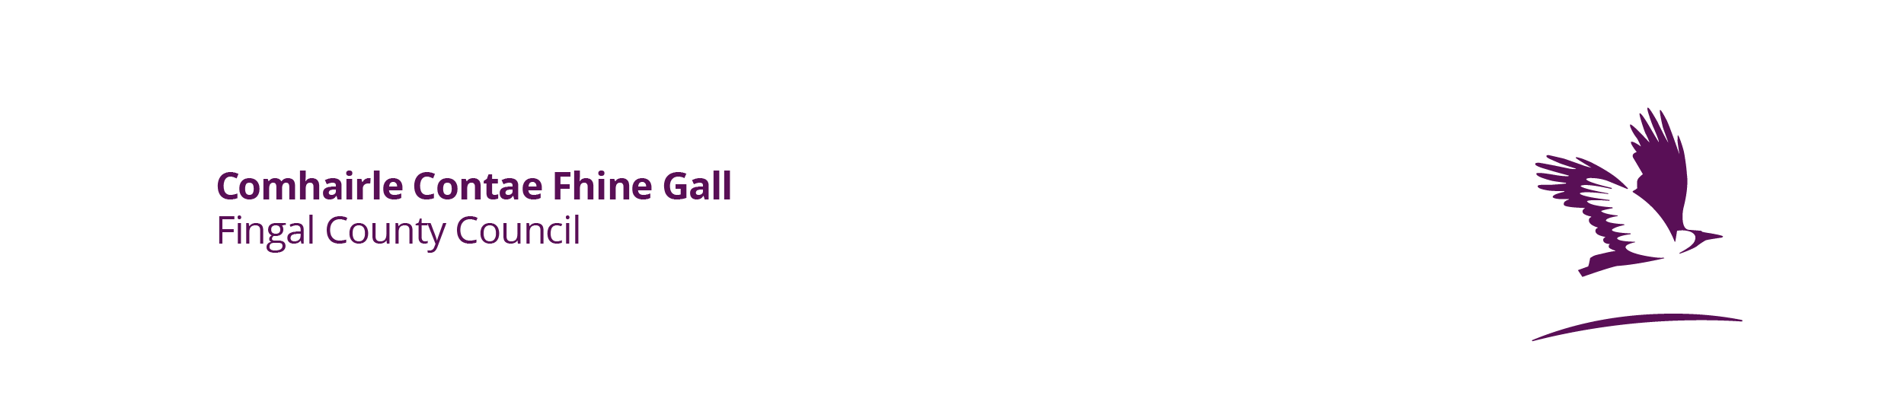
Vehicle Refinishers–
New/Renewal Application Form for the Certificate of Compliance

1. Name, address, email, contact phone number for the operator:

2. Address of the Vehicle Refinishing premises if different from above:

3. (a) Have you previously been issued with a certificate for this installation? Yes/No (Cross out as appropriate)
(b) If yes to 3(a), please state the date of expiry of the previous certificate:

Enclosed*:
❒ Enviroguide Report on the compliance of the vehicle refinishing operation; and

❒ Payment/proof of payment of application fee of €50/€70 payable to the local authority

Signature..................................................................

Date..................................

*Please submit the competed application form, Enviroguide report and payment/proof of payment of application fee either in hardcopy to the Environment Section, Fingal County Council, County Hall, Main Street, Swords, Co. Dublin, K67 X8Y2 or via email to enviroment@fingal.ie.

The fee must be paid at the time of application. This can be paid either via cheque or over the phone with the Fingal County Council Cash Office Section (01-8905154) between 9.30am – 15.30am Monday to Friday. Please quote reference code ‘EN063 Solvents Directive – Cert’ at the time of payment.

